**Project Design Phase-II**

**Requirement Analysis**

|  |  |
| --- | --- |
| **Date** | **02 November 2023** |
| **Github name** | **[74BC4F37853BF1E8045468DA6E31B6A0-SALESFORCE](https://github.com/Kiruthikaduraiyarasan/74BC4F37853BF1E8045468DA6E31B6A0-SALESFORCE/tree/main)** |
| **Project Name** | Recruiting Assistance For The HR Managers |

### **Technical Architecture :**

Designing a technical architecture for recruiting assistance for HR managers involves creating a structured framework for the various software and systems that will support HR managers in their recruitment tasks. Here's a high-level technical architecture for such a system:

**User Interface (UI):**

* Web-based or mobile application for HR managers to access the recruiting assistance system.
* User-friendly dashboard for easy navigation and task management.
* Customization dashboards for different HR roles and responsibilities.

**Applicant Tracking System (ATS):**

* Central component for managing the recruitment pipeline.
* Stores candidate data, job postings, and job requisitions.
* Provides tools for HR managers to review, screen, and shortlist candidates.
* Integration with job boards and career websites for posting job openings.

**AI and Automation Layer:**

* AI-powered tools for resume screening and initial candidate assessment.
* Chat bots for candidate engagement and initial inquiries.
* Natural Language Processing (NLP) for parsing and understanding candidate resumes and job descriptions.

**Candidate Relationship Management (CRM):**

* CRM functionality for tracking and managing candidate interactions.
* Automated email and communication tools for staying in touch with candidates.
* Integration with social media and professional networks for sourcing passive candidates.

**Video Interviewing Platform:**

* Integration with video interviewing software for conducting remote interviews.
* Recording and playback capabilities for HR managers to review interviews.
* Candidate evaluation tools to assess interview performance.

**Assessment and Testing Tools:**

* Integration with pre-employment testing and assessment platforms.
* Provides HR managers with the ability to create and send assessments to candidates.
* Collects and analyzes assessment results.

**Collaboration and Communication Tools:**

* Integration with collaboration tools like Slack, Microsoft Teams, or email.
* Real-time chat and messaging features for HR managers to discuss candidates and hiring decisions.
* Document sharing and collaboration for interview feedback and evaluations.

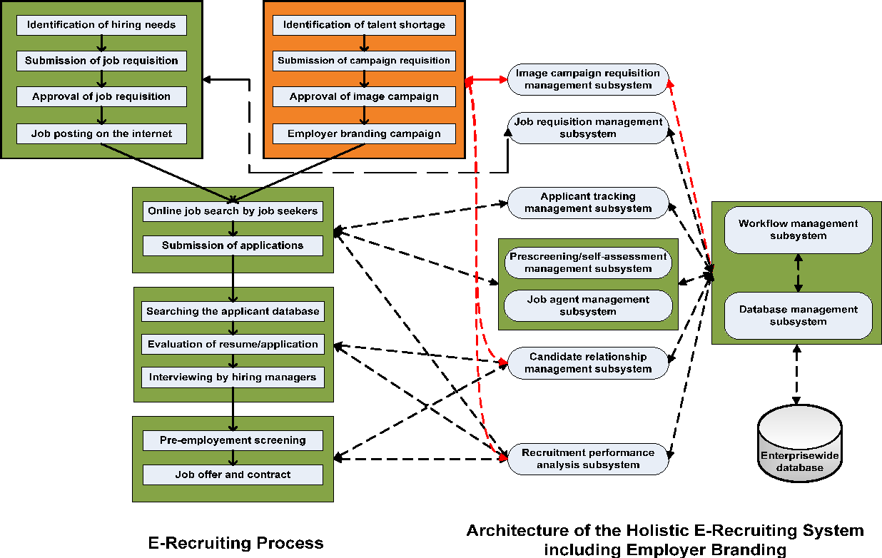

**Data Analytics and Reporting:**

* Analytics engine for monitoring and reporting on recruitment KPIs.
* Customizable reports and dashboards for HR managers and leadership.
* Machine learning algorithms for predictive analytics on hiring trends.

**Backup and Disaster Recovery:**

* Regularly back up critical data and establish a disaster recovery plan to minimize downtime in case of system failures or data breaches.

**Continuous Integration and Deployment (CI/CD):**

* Automate the CI/CD pipeline to streamline development, testing, and deployment of new features and updates.

**Data Analytics and Reporting:**

* Integrate data analytics tools to generate reports and insights, helping HR managers make data-driven decisions.

**Feedback Mechanism:**

* Include feedback mechanisms for HR managers to report issues and suggest improvements.

**Compliance Auditing:**

* Implement an auditing system to track changes to sensitive data and ensure compliance with internal policies and external regulations.

**Mobile Application Support:**

* Consider developing a mobile app for HR managers to access the recruiting assistance system on the go.

**Documentation and Training Resources:**

* Provide comprehensive documentation and training materials for HR managers and other users to maximize the system's benefits.

**Quality Assurance and Testing:**

* Implement a robust testing framework, including unit testing, integration testing, and user acceptance testing, to ensure the system's reliability.